Problem 15.33

(Term Project) Draw up black-box test cases for the product you specified in Problem 12.20 or 13.22. For each test case, state what is being tested and the expected outcome of that test case.

Step-by-step solution

1. **Step 1** of 3

**Test cases for chocoholic’s anonymous software using black-box testing:**

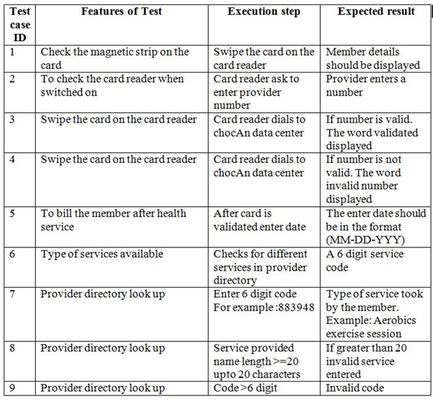

[Comment](javascript:;)

1. **Step 2** of 3

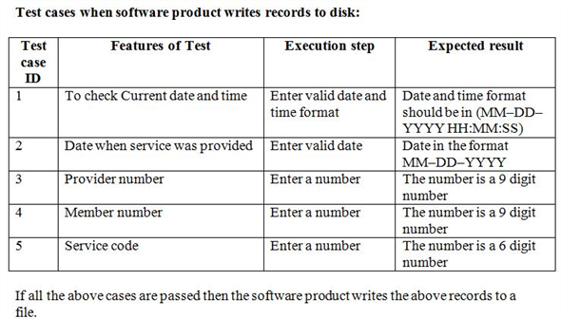

[Comment](javascript:;)

1. **Step 3** of 3

